Assignment 6

- (20 pts.)
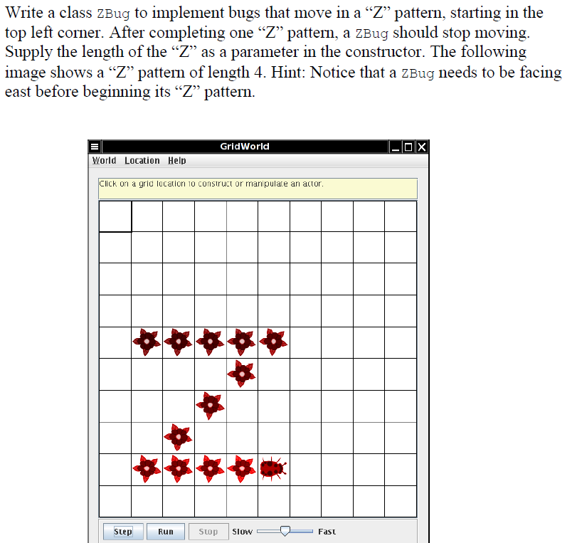
Test the class.

